CMPS 350- Web Development Fundamentals

**Assignment 1**

|  |  |
| --- | --- |
| **Student Name** | Nasser Alkuwari |
| **Student Id** | na2207504 |
| **Email** | Na2207504@qu.edu.qa |

**Grading Rubric - - In the *Functionality* column please specify either: *Working (completed x%)*, *Not Working (completed x%)* or *Not done*.**

|  |  |  |  |  |
| --- | --- | --- | --- | --- |
| Criteria | % | Functionality* | Quality of the implementation (Instructor Feedback) | Score |
| -Used proper HTML-5 Tags and Semantic for all the three pages [30] | 40 | ***Working 100%*** |  |  |
| -Correctly replicated the page design  -Made all the three pages Responsive using media queries , flex-box and Grid | 60 | ***Working 100%*** |  |  |
| Did Not Submit the testing sheet | -10 |  |  |  |
| Total | 100 |  |  |  |
| Copying and/or plagiarism or not being able to explain or answer questions about the implementation | -100 |  |  |  |

**Possible grading for functionality**:

* ***Complete and Working*** (get 70% of the assigned grade),
* ***Complete and Not working*** (lose 60% of assigned grade)
* ***Not done*** get 0.
* The remaining grade is assigned to the quality of the implementation.
* Must submit screenshots in this **Testing-GradingSheet.docx** (otherwise - 10pts).

## Testing evidence

Add the screenshots of your working website here.

## Home page

## Big Screen

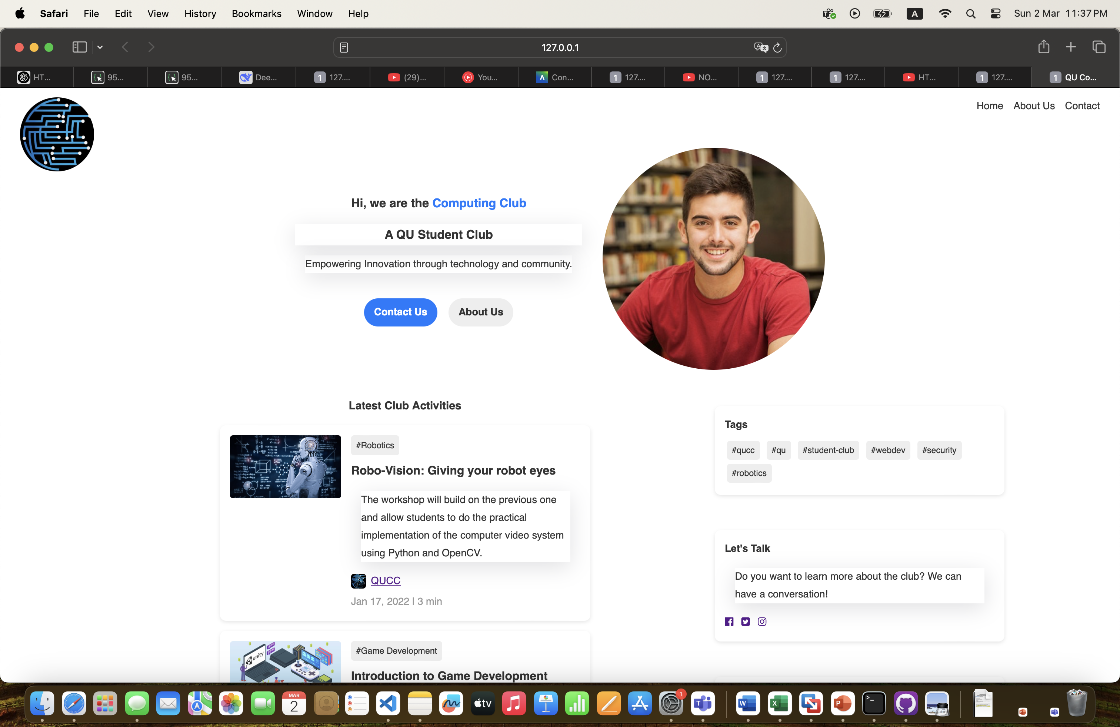

## Medium Screen

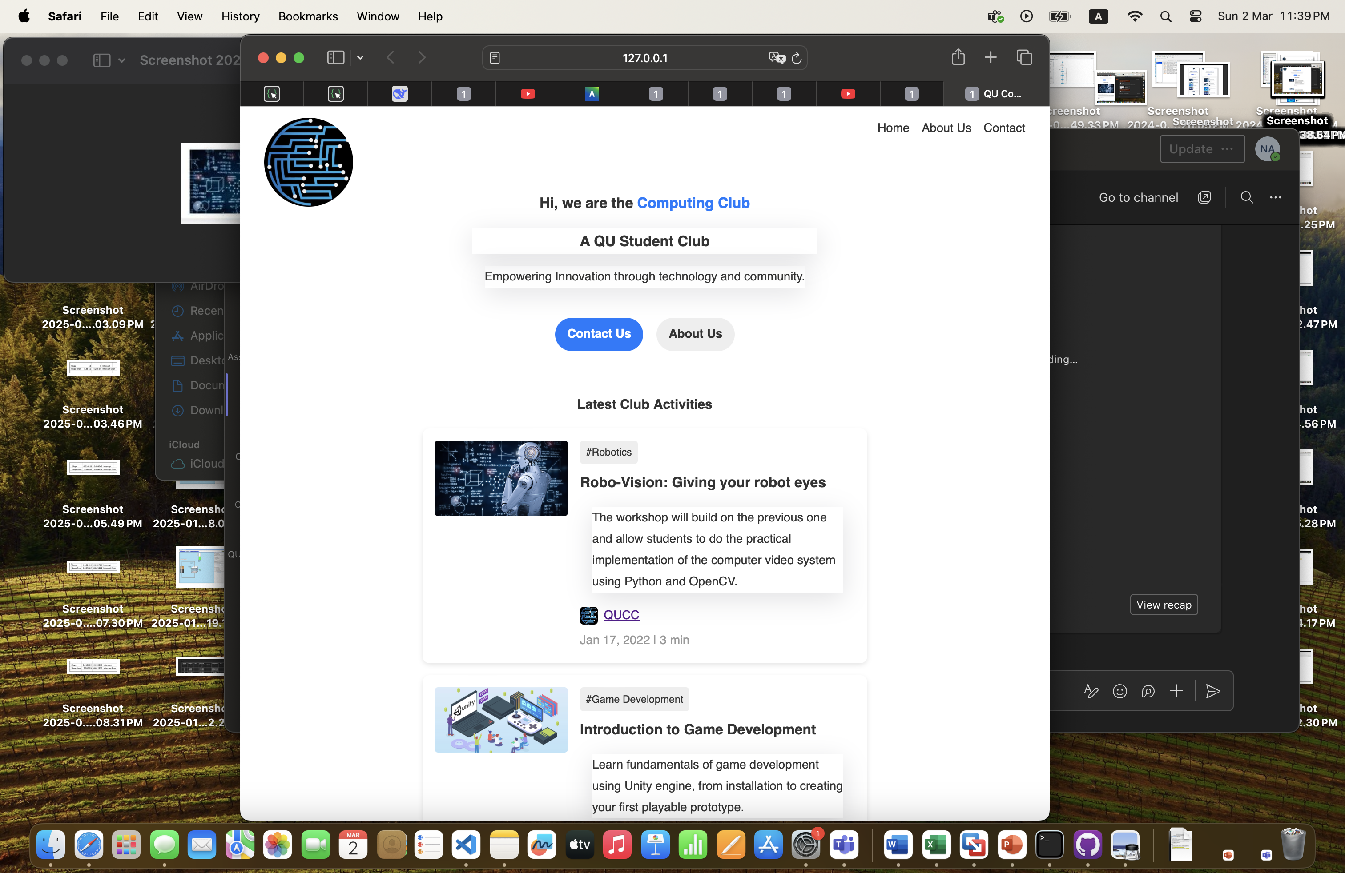

## Small Screen

